Instructions for Returning Volunteer/Employee
Returning Individuals are required to reactivate their compliance account by completing the Online Background Check Application. Contact your Child Protection Liaison at the parish/school where you will be providing service.
Information you will need to Collect Before Starting the Application Online
- You will need your Username
  - *Don’t know your username*
  - Send an Email to opcypsupport@arlingtondiocese.org
    - Email must include: your full name, last 4 digits of social or date of birth, and the name of the location where you will be working or volunteering for.
- You will need one of the following: Driver’s License, State Issued ID, Passport #, Social Security # or ITIN
- 15 Years Residence History: Must provide address history
- Family Information: List full legal names and date of births
  - Spouse information, previous marriages, children including foster children, stepchildren, adult children, and those not living with you
- Criminal History Information (i.e., charges/convictions, jurisdiction, approximate date)
- 5 Years of Employment History: Provide the last 5 years of Employment History. If you were a student or homemaker, information should be included.

Ready to Visit the Online Application Website:
- Begin by selecting the link below and Sign In on the left-hand side. Do not create a new account!
Visit: https://www.arlingtondiocese.org/child-protection/
- Select: Employee or Volunteer as displayed below.

- Login on the Left-Hand Side. Do not create a new Account!
  - 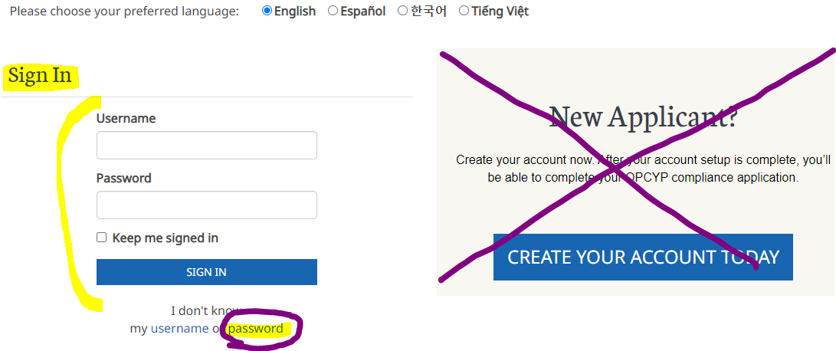

- Sign in and complete each section of the application by selecting “edit”.
- After submitting your application, please sign forms on DocuSign

*Recognized Mistakes on DocuSign Need Help- https://opcypsupport.freshdesk.com/a/solutions/articles/44002374395?lang=en
- The Child Protection Liaison at the location you will be providing service will review you signed DocuSign forms and will “approve” or “decline”.

What to expect after the Liaison Approving DocuSign?

- National Center for Safety Initiatives (NCSI) Background Check will take place!
  - Contact the Child Protection Liaison for an update on your results and when you may begin working or volunteering.
  - Results are posted and provided to the Liaison within 2-7 Business Days.

- Did you receive an NCSI Identity Verification Email?
    - NCSI on occasion may need to verify additional information to successfully run a background check.
    - You have 30 days to respond to NCSI by email or their toll-free number.
    - NCSI Email: verification@ncsisafe.com
    - NCSI Phone #: 1-866-996-7412

- Previous Compliance Items Completed will not be required to reactivate your account!
VIRTUS Training
    - You will not need to retake VIRTUS training.
    - Transfer VIRTUS training from another Diocese to the Diocese of Arlington:
      - Contact the VIRTUS help desk via phone at (888) 847-8870 or email helpdesk@virtus.org to request that your account be transferred.
Central Registry Form (CPS Form)
- You will not be required to resubmit another CPS form.
Employee Fingerprint Check
  - You will not be required to resubmit another Employee Fingerprint.

