Before attending an initial facilitator-led Protecting God’s Children training, you must first register through VIRTUS Online.  Please register by going to:  https://www.virtusonline.org/virtus/reg_2.cfm?theme=0&org=18408  Or you can also go to www.virtus.org and click on ‘First-Time Registrant’ and select Arlington, VA (Diocese) from the dropdown list. | 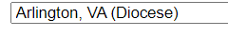
Create a user ID and a password you can easily remember.  This is necessary for all participants. This establishes your account with the VIRTUS program. If your preferred user ID is already taken, please choose another ID.  Click Continue to proceed. | 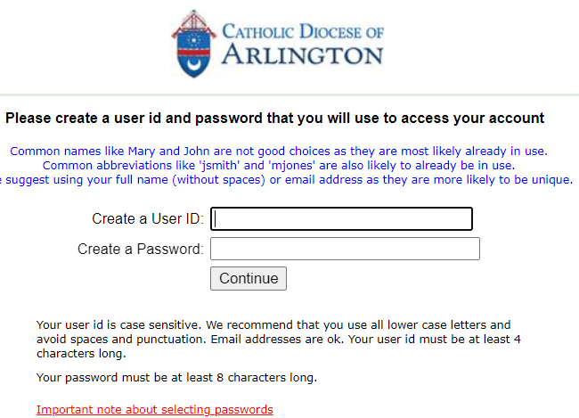
Provide all the information requested on the screen.  Several fields are required, such as: First, Middle & Last Name, Email address, Home Address, City, State, Zip, Phone Number, Date of Birth, Driver’s License and State, and any additional names.  (Note: Do not click the back button or your registration will be lost.)  Click Continue to proceed. | 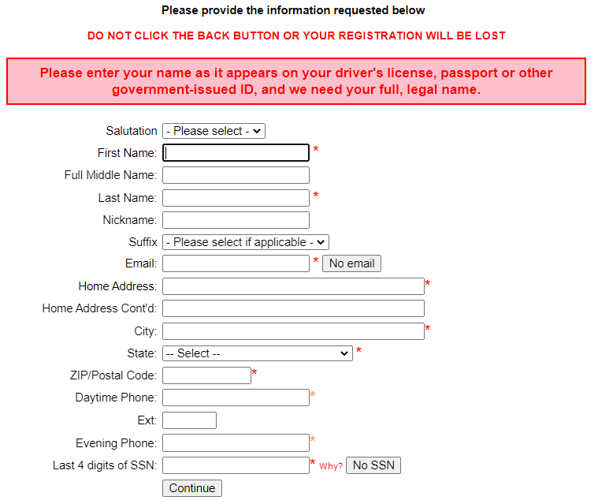
Select the Primary location where you work or volunteer by clicking the downward arrow to select a parish, school or diocesan site and then select your associated Role(s) with this location.  Next, select the specific Position(s) of Service for the identified roles.  Finally, enter your title or a brief description of what you do.  Click Continue to proceed.  Note: If you serve at multiple diocesan locations, you will be prompted to select those additional locations next. | 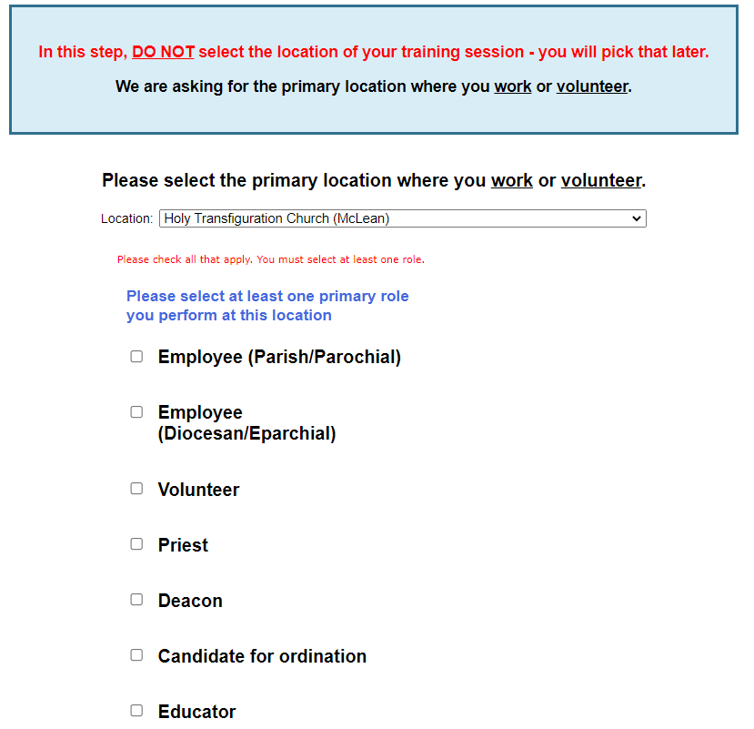  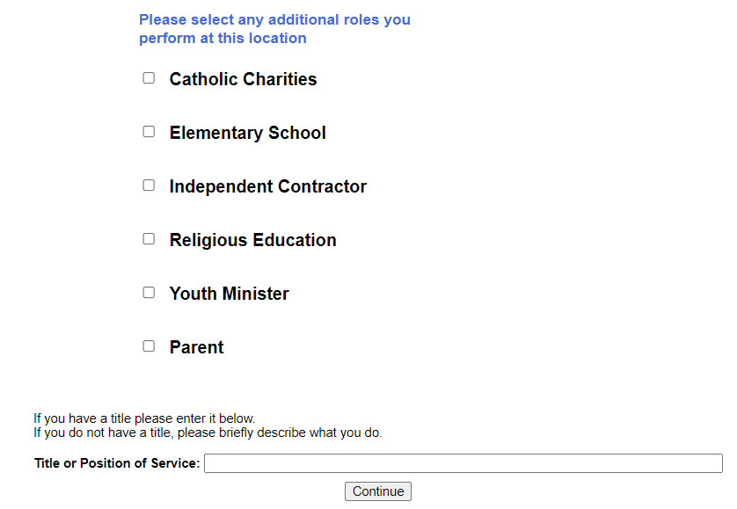
Your selected location(s) and role(s) are displayed on the screen.  Select YES, if you need to add secondary/additional locations and roles.  Otherwise, if your list of locations is complete, select NO. | 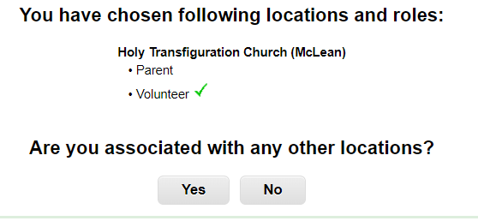
Please answer Yes or No to the questions presented.  Click Continue to proceed. | 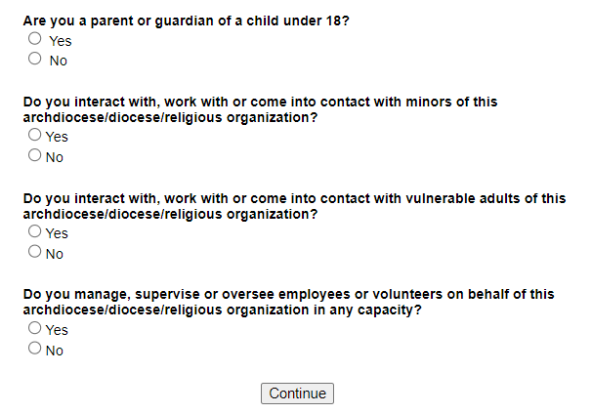
Answer YES or NO to the question of “Have you already attended a VIRTUS Protecting God’s Children Session?  If you attended a session select YES, you will be presented with a list of sessions that already occurred. Choose the session you attended by clicking downward and highlighting the session and then click Complete Registration. | If you attended a session already:
To complete your VIRTUS registration, your final step is to sign up for an instructor-led Protecting God’s Children® training session from the schedule provided. Select the session you wish to attend (click the circle) and click Continue to complete your registration and return to your VIRTUS Online account.  The schedule is updated continuously so please login to your account regularly to get signed up for a training session as soon as possible. | 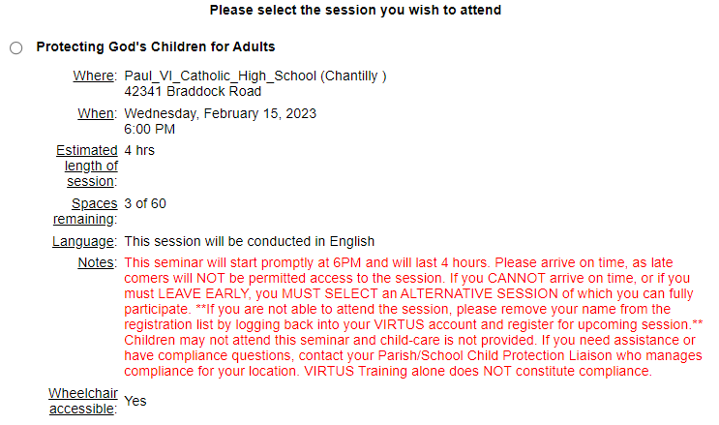
Your registration is complete when you see this message. | 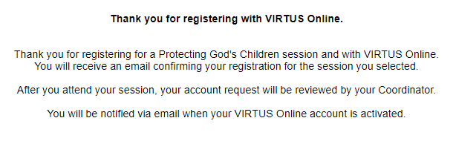
If you have additional questions about VIRTUS Online training, please contact your local administrator, or the VIRTUS Help Desk at 1-888-847-8870.

