Instructions for Returning Volunteer/Employee
Returning Individuals are required to reactivate their compliance account by completing the Online Background Check Application.
Completed forms/Training in the past?
If you’ve completed a CPS Form or VIRTUS Training in the past, you are not required to complete it again. If you are a returning employee and you’ve completed Fingerprints, you are not required to complete it again.
For further assistance, contact your Child Protection Liaison at the parish/school where you will be providing service.
Collect Information Before Starting the Application Online
- You will need one of the following: Driver’s License, State Issued ID, Passport #, Social Security # or ITIN
- Residence History: Last 15 years of Address History
- Family Information Full Legal Names: Spouse information (previous marriages), Children’s Date of Birth (including foster children, stepchildren, adult children, and those not living with you)
- Criminal History Information (i.e., charges/convictions, jurisdiction, approximate date)
- Employment History: Last 5 years of Employment History. If you were a student or homemaker, information should be included.

Ready
- Application Type Select: Volunteer
- Volunteer Position Title (provided from your Child Protection Liaison)
- Parish/School Location Name: Select correct Location where you will be volunteering.
- You will need your Username

Ready to Visit Website
- Complete the Online OPCYP Application
Visit: https://www.arlingtondiocese.org/child-protection/
Select: Employee or Volunteer
Login on the Left-Hand Side (Do not create a new Account) 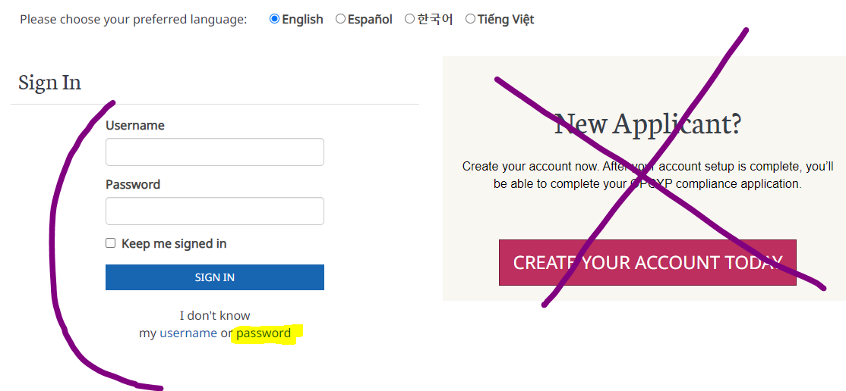

*Don’t know Username: Contact your Child Protection Liaison and request your username.
*Don’t Know Password*:
  - Type your username (Contact your LIAISON if you don’t know your username)
  - An automated email will be sent providing a link to reset password
  - Return to the OPCYP application link above (step 1)

- Sign in and complete each section of the application by selecting “edit”.
- After submitting your application, please sign forms on DocuSign
*Recognized Mistakes on DocuSign Need Help- https://opcypsupport.freshdesk.com/a/solutions/articles/44002374395?lang=en
- You Liaison will review you signed forms and will “approve” or “decline”.

Actions Upon Completion of the Application

- DocuSign Email: Sign your compliance forms using DocuSign.
  - *Recognized Mistakes on DocuSign Need Help- https://opcypsupport.freshdesk.com/a/solutions/articles/44002374395?lang=en
- Liaison will Review Forms
- Background Check Results post within 2-7 Business Days
  - NCSI (National Center for Safety Initiatives): run the background check screening.
  - After 7 Days: On NCSI may to verify information to continue with the background check Screening.
  - Received an NCSI Verification Email: You have 30 days to respond to NCSI by email or their toll-free number. Failure to respond will cancel your background check. You will then need to contact your Liaison for assistance to run another background check with NCSI.
    - NCSI Email: verification@ncsisafe.com
    - NCSI Phone #: 1-866-996-7412

