The Diocese of Arlington requires volunteers with substantial contact with children must complete their Online Background Check Application prior to volunteering as part of their compliance. Your continued volunteer service is conditioned upon completing the application, passing all background checks, and completing VIRTUS Training. The online application should take approximately 20-30 minutes. If you need additional assistance, please contact the Child Protection Liaison at your volunteer location.
Volunteer Online Background Check Instruction Guide
Information Needed to complete the Online Background Check
- Use Legal Name
- Email Address
- Application Type Select: Volunteer
- Volunteer Position Title (provided from Child Protection Liaison)
- Parish/School Location (must distinguish Parish or School Name): Select correct Location
- Provide one of the following: Driver’s License, State Issued ID, Passport #, Social Security # or ITEN
- Residence Information: Last 15 years of Address History
- Family Information for CPS: Spouse information (previous marriages), Children’s Full Legal Name & Date of Birth (including foster children, stepchildren, adult children, and those not living with you)
- Criminal History Information (i.e., charges/convictions, jurisdiction, approximate date)
- Employment History for the last 5 years (If you have worked for the same company for the past five years, provide at least one other employer if possible. If you were a student, provide the school information)

Follow Steps to Begin the Online Background Application

Step 1: Select the Volunteer Link below:

https://secure4.arlingtondiocese.org/OPCYP_Application/Volunteer_Home.aspx

Step 2:
New User: If you are new, select “Create Your Account Today”

Returning User: If you are returning and have previously completed background check forms for the Office of Child Protection, you will need to reactivate your compliance account. Please sign in on the left-hand side as displayed below. Provide your username and password. If you don’t know your username, contact you child protection liaison for further instruction.

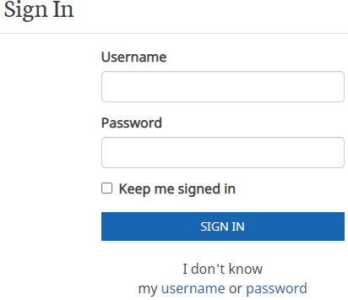

ERROR MESSAGE: SSN/ITEN IS ALREADY IN USE
If the SSN/ITEN number is already in the diocesan database, the following error message displays. Contact https://OPCYPSupport.freshdesk.com for assistance.
Step 3: Complete each section of the online background check application. Provide the information requested in each field. Fields with an * are required fields.
  - Applicant Information
  - Personal Information
  - Criminal Information
  - Employment/Volunteer History
Step 4: Submit your Application.
Step 5: Select Sign Documents.
Step 6: Go to your email and open the DocuSign automated email. You will receive an email notification regarding legal documents you need to sign within 48 hours.
Step 6: Review each Diocesan Form carefully.
- If you find errors, decline to sign the forms, return to the application and log back into your account. Select “edit” to make the needed changes, and then resubmit your application. The DocuSign email will recreate your forms for signature.
Step 7: Provide your electronic Signature on the forms. When finished, click Finish.
- If you wish to save your completed forms, click the Download button
- If you wish to print your completed forms, click the Print button.
Step 8: DocuSign will send your signed forms to your Liaison for their review and approval.
Liaison will approve/decline
  - If approved: the background check will take place.
  - If declined: log back into your online background check application, return to the application and log back into your account. Select “edit” to make the needed changes, and then resubmit your application. The DocuSign email will recreate your forms for signature. Check email to electronically sign forms on DocuSign.

Next Steps: Upon Forms Approval

National Center for Safety Initiatives (NCSI): runs the background check screening. Results are completed within 2-7 business days. On occasion, NCSI may need to verify information to continue with the background check screening process. NCSI will contact you directly by email. If the information is not received within 30 days of the original submission date, the screening request will be cancelled. You may contact NCSI by email verification@ncsisafe.com or their toll-free number is 1-866-996-7412.

Central Registry Form CPS must be Notarized: Coordinate with your Liaison to have the form notarized. The form must be signed in front of a notary public. Do not sign the form before appearing before the notary. Return the notarized form to your Liaison. You have 30 days to return the CPS form to your Liaison.

To avoid common errors that will cause the delay or disqualification of the CPS form, review the Avoid Common Errors: https://www.arlingtondiocese.org/uploadedfiles/cda/pages/child_protection/child_protection/background_check/common_cps_form_errors.pdf

If your CPS is rejected due to errors found on the CPS form, you may complete a new CPS form by completing the form on a computer, entering your information then printing the document with the data pre-entered.
https://www.arlingtondiocese.org/uploadedfiles/cda/assets/pdf/child_protection/bgc-department-of-social-services-request.pdf

